**Challenge Name: Essay**

**Description**  
I've written an essay for my assignment. Could you please take a look at it?

**Solution**

Using file command found this  


But after inspecting using hex dump found “PK” which means it’s a zip



Then unzipped it using unzip command and extracted all files

Then tried strings commands on each file using grep to find “Blitz” as it’s the starting of the flag

Then tried to use grapping using “QmxpdHp” which is the encryption of “Blitz” and found this  
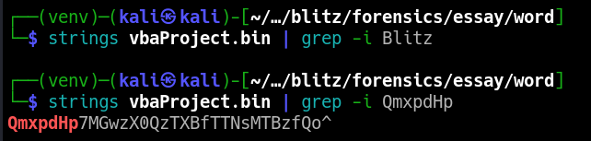

After decoding this found this flag, “Blitz{0l3_D3Mp_M3l10s}”